**Bahamian Boiled Fish**

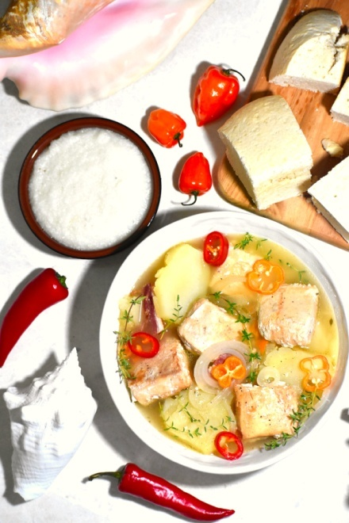

## INGREDIENTS

* 2 lbs fish
* 1 lb potatoes
* 1 medium onion
* 2 oz bacon or salt pork
* Juice of 3-6 limes, depending on taste preference
* 1 hot pepper, like scotch bonnet
* 7-8 sprigs of fresh thyme, or 1.5 tsp dried
* Water
* Salt and pepper to taste
* 1-2 tsp hot sauce

## METHOD

1. Cut fish into large chunks and marinate with juice of 1-2 limes, plus 1-2 tsp hot sauce, depending on desired spice level.
2. Cut bacon into 2 inch strips and fry until browned, but not crispy, in a 4-5 qt pot. Remove.
3. Cut onions into rings and potatoes into 3/8 inch slices.
4. In same pot, layer fish, potatoes, thyme, chopped hot pepper, onions and bacon. Add salt and pepper. Fill pot with water until potatoes are completely covered. Add juice of 2-3 more limes. Bring to low boil, reduce heat to low, cover and simmer until potatoes are cooked but still firm, about 15-20 minutes.